Framework Workflow System
End-to-End Process: Creation → Approval → Company Assignment

Document Date | 02 April 2026
Prepared By | Saksham Kamboj
Subject | Framework Lifecycle & Version Management Workflow

1. Overview
This document describes the complete lifecycle of a Framework within the system — from initial creation by the Admin, through Expert review and AI-powered extraction, to approval and assignment to companies. It also covers the version management strategy for both major framework versions and minor file-level versions.

The workflow involves three primary roles:
- Admin — Creates categories, grants access, and assigns frameworks to companies.
- Expert — Uploads framework files, sends them to AI, reviews and manages extracted controls, and approves the final framework.
- AI Engine — Processes uploaded framework files and generates structured controls for Expert review.

2. Framework Workflow — Step by Step

2.1 Framework Creation & Access
- Step 1 — Framework Category:
- Admin creates a framework category (e.g., ISO 27001, SOC 2, GDPR).
- This defines the scope and type of the framework.
- Step 2 — Framework Access:
- Admin assigns one or more Expert users to the framework category.
- Expert receives access to upload and manage frameworks under that category.

2.2 Expert Upload & AI Processing
- Step 3 — Upload Framework Files:
- Expert uploads framework documents (PDF, DOCX, etc.) to the system.
- Each file gets a File Version (e.g., v:1.0.0). The overall framework also carries a Main Version (e.g., ISO 27001:2022).
- Files can be uploaded individually and each can be sent to AI separately.
- Step 4 — Upload to AI:
- Expert sends uploaded files to the AI engine for processing.
- Multiple files can be queued for extraction independently.
- Step 5 — AI Extraction:
- AI engine parses framework content and automatically generates structured controls and mappings.
- Output is staged for Expert review before any data is finalised.

2.3 Expert Review & Approval
- Step 6 — Review & Manage AI Extraction Controls:
- Expert reviews all AI-generated controls.
- Expert can Add new controls, Update existing ones, or Delete incorrect entries.
- Manual edits are also permitted at this stage.
- Step 7 — Expert Approval Decision:
- If Expert approves → the framework is frozen and becomes a stable version.
- If Expert does not approve → the system allows either a retry (re-run AI extraction) or a manual update, then loops back to Step 5 or 6.

2.4 Freeze & Assignment
- Step 8 — Freeze Framework:
- On approval, the framework version is locked (frozen).
- This creates a production-ready, stable framework version that can be assigned to companies.
- Step 9 — Admin Assigns to Company:
- Admin selects one or more companies and assigns the approved stable framework to them.
- The company starts auditing based on the assigned framework version.
- Step 10 — Company Audits:
- The company conducts ongoing audits as per the assigned framework version.
- All audit activities are tracked against the specific version the company is on.

3. Version Management Strategy

3.1 Version Structure
Every framework has two independent version identifiers maintained simultaneously:

Version Type | Format / Example | Trigger | Impact on Company
Main (Framework) Version | ISO 27001:2022 | Major structural / standard changes | Company stays on old version; must request upgrade
File (Minor) Version | v:1.0.0 → v:1.0.1 → v:1.0.2 | Minor edits / updates to individual files | Auto-reflected as minor update; no disruptive impact

3.2 Minor Version Update (File-Level)
When an Expert updates an individual file within an existing framework:
- The file's version increments (e.g., v:1.0.0 → v:1.0.1).
- Companies assigned to the framework are not significantly affected.
- The minor change is reflected automatically in the company's audit scope.
- No new assignment request is needed from the company.

3.3 Major Version Update (Framework-Level)
When significant structural or standards-level changes are made:
- The Main Framework Version is updated (e.g., ISO 27001:2013 → ISO 27001:2022).
- The previous stable version remains locked and accessible.
- Companies currently using the old version continue without disruption.
- A notification is sent to all assigned companies informing them of the new version.
- If a company wishes to upgrade, they must raise an upgrade request to the Admin.
- Admin reviews the request and assigns the new framework version to the company.

4. Workflow Step Reference
Step | Role | Description
1 | Admin | Creates the framework category that defines the scope and type of the framework.
2 | Admin | Assigns one or more Expert users access to the framework category.
3 | Expert | Uploads framework files. Each file receives a File Version (v:1.0.0). Framework carries a Main Version.
4 | Expert | Sends uploaded framework files individually to the AI engine for extraction.
5 | AI Engine | Processes files and auto-generates structured controls, mappings, and audit data.
6 | Expert | Reviews AI extraction output. Can Add, Update, or Delete controls. Manual edits permitted.
7 | Expert | Decision: Approve → Freeze framework. Reject → Retry AI or manually update (loop back to 5/6).
8 | System | Framework is frozen into a stable, production-ready version ready for assignment.
9 | Admin | Assigns the approved stable framework to one or more companies.
10 | Company | Conducts audits according to the assigned framework version.

5. Framework Workflow Flow Diagram
The diagram below illustrates the complete end-to-end workflow described in this document.

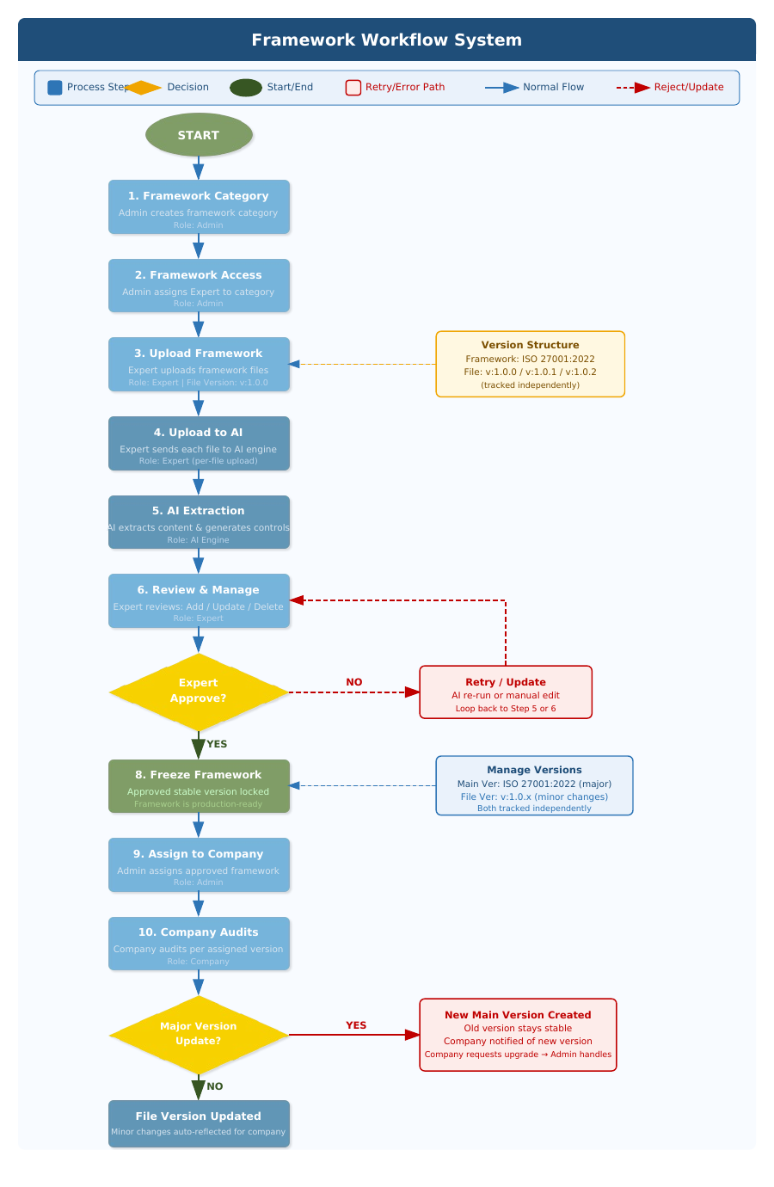

Figure 1: Framework Workflow System — End-to-End Flow Diagram

